PROJECT REPORT OF CO-OP Project at Industry (Module-2)
ON
Secure File Sharing using Blockchain
submitted in partial fulfilment of the requirements for the award of degree of

BACHELOR OF ENGINEERING
In
COMPUTER SCIENCE AND ENGINEERING

Submitted by: Supervised By:
Aditya Kumar (2210990067) Dr. Gifty Gupta
Agrim (2210990079) Assistant Professor
Chitkara University Rajpura, India


DEPARTMENT OF COMPUTER SCIENCE AND ENGINEERING

CHITKARA UNIVERSITY INSTITUTE OF ENGINEERING AND TECHNOLOGY
CHITKARA UNIVERSITY, PUNJAB, INDIA

CONTENTS

S.No. | Title | Page No.
 | Acknowledgement | iv
 | List of Figures and Tables | v
 | Abstract
1 | Introduction | 1
2 | Methodology | 1 - 2
3 | Tools and Technologies | 2
4 | Implementation | 2 - 5
5 | Major Findings/Outcomes/Output/Results | 5
6 | Conclusion and Future Scope | 5
 | References | 5
 | Appendices

DECLARATION

I hereby certify that the work which is being presented in the project report entitled “Secure File Sharing using Blockchain” in partial fulfilment of requirement for the award of the degree of Bachelor of Engineering (Computer Science and Engineering) submitted in the department of Computer Science and Engineering at Chitkara University Institute of Engineering and Technology, Chitkara University, Punjab, India, is an authentic record of my own work carried out under the supervision of Dr. Gifty Gupta. The matter presented in this project report has not been submitted in any other university/institute for the award of any degree.

Place: Rajpura (Name of the Student)
Date: 29th April 2026 Aditya Kumar (2210990067)
Agrim (2210990079)

This is to certify that the above statement made by the candidate is correct to the best of my knowledge and belief.

Dr. Gifty Gupta
Assistant Professor
Department of Computer Science and Engineering
Chitkara University Institute of Engineering and Technology,
Chitkara University, Punjab, India

ACKNOWLEDGEMENT
I would like to express my sincere gratitude to my mentor Dr. Gifty Gupta for their constant guidance, valuable suggestions, and encouragement throughout the development of this project. Their support played a crucial role in completing this work successfully.
I would also like to thank the faculty members of the Department of Computer Science and Engineering, Chitkara University Institute of Engineering and Technology, for providing the necessary resources and academic environment required for this project.
Finally, I extend my gratitude to my family and friends for their constant motivation and support.
ABSTRACT
With the rapid advancement of digital technologies, secure file sharing has become a significant concern across various industries. Traditional file sharing systems rely heavily on centralized storage, which makes them vulnerable to data breaches, unauthorized access, and single points of failure. These limitations reduce trust and compromise data integrity.
This project proposes a secure file sharing system by integrating Blockchain technology with the InterPlanetary File System (IPFS). In this system, IPFS is used to store files in a decentralized manner, while blockchain is utilized to store cryptographic hashes of these files, ensuring immutability and integrity. Each file is assigned a unique content identifier (CID), which acts as a fingerprint of the file.
The system allows users to upload, store, retrieve, and verify files securely. By combining blockchain and IPFS, the proposed solution enhances security, reduces storage redundancy, and improves transparency. The system demonstrates improved resistance to cyber-attacks and provides a reliable mechanism for secure digital communication.

- Introduction
  - Background
In today’s digital era, the exchange of data has become an integral part of various industries such as healthcare, finance, and education. With the increasing dependence on digital systems, ensuring secure data sharing has become a major concern. Traditional file sharing systems rely on centralized servers, where all data is stored and managed by a single authority.
This centralized approach makes the system vulnerable to cyber-attacks, data loss, and unauthorized access. If the central server fails, the entire system becomes inaccessible, leading to significant risks. Therefore, there is a need for a decentralized solution that eliminates these limitations and provides a secure environment for data sharing.

  - Problem Statement
Traditional file sharing systems face several critical issues that affect their reliability and security. These systems are highly dependent on centralized storage, which creates a single point of failure. In case of server failure or cyber-attack, the entire data can be compromised or lost.
Moreover, these systems do not provide strong mechanisms for verifying data integrity, making it difficult to detect unauthorized modifications. The cost of maintaining centralized infrastructure is also high. These challenges highlight the need for a more secure, efficient, and decentralized file sharing system.

  - Objectives
The main objective of this project is to design and implement a secure file sharing system using blockchain and IPFS technologies. The system aims to provide a decentralized architecture that ensures data integrity, enhances security, and reduces storage costs.
Additionally, the project focuses on improving transparency and reliability while eliminating the dependency on a central authority.

- Methodology
  - System Architecture
The proposed system follows a layered architecture to ensure modularity and efficiency. The architecture consists of four main layers that work together to provide a secure file sharing environment.
- The User Interface Layer allows users to interact with the system through a web-based application developed using React.js. It provides functionalities such as file upload and retrieval.
- The Storage Layer uses IPFS to store files in a decentralized manner. IPFS divides files into smaller chunks and distributes them across multiple nodes, ensuring high availability and fault tolerance.
- The Blockchain Layer uses the Ethereum network to store the content identifiers (CIDs) generated by IPFS. These CIDs act as unique references to the files and ensure immutability.
- The Security Layer integrates MetaMask, which provides secure authentication and manages transactions between the user and the blockchain.

  - Workflow of the System
The workflow of the system begins when a user selects a file for upload. The selected file is sent to IPFS, where it is processed and assigned a unique content identifier (CID). This CID is generated using cryptographic hashing based on the file content.
Once the CID is generated, it is stored on the blockchain using a smart contract. This ensures that the file’s identity is permanently recorded and cannot be altered.
When a user wants to retrieve the file, they use the CID to access it from IPFS. After retrieval, the system verifies the file’s integrity by recalculating its hash and comparing it with the stored CID. If both values match, the file is considered authentic.

  - Mathematical Model
The system uses cryptographic hash functions to ensure data integrity. The content identifier (CID) is generated using a hash function, which can be represented as:
CID = H(file)

During file retrieval, the system verifies integrity using the following condition:
H(retrieved file) = H(original file)

If the two hash values are not equal, it indicates that the file has been modified or tampered with. This mechanism ensures that any unauthorized changes can be easily detected.

- Tools and Technologies
  - Blockchain Technology
Ethereum is used as the blockchain platform in this project. It provides a decentralized and immutable ledger for storing file hashes. Smart contracts are used to store and manage these hashes securely.

  - IPFS (InterPlanetary File System)
IPFS is a distributed file storage system that allows files to be stored across multiple nodes. It improves data availability and reduces redundancy by using content-based addressing.

  - Pinata
Pinata is used as a pinning service for IPFS. It ensures that files remain available on the network and are not removed over time.

  - Frontend and Tools
The user interface is developed using React.js, which provides a responsive and interactive platform. Remix IDE is used for developing and deploying smart contracts. MetaMask is used as a digital wallet and authentication tool for secure communication with the blockchain.

- Implementation
  - File Upload Process
The implementation begins with the user uploading a file through the interface. The file is then sent to IPFS using the Pinata service, where it is stored in a decentralized manner.
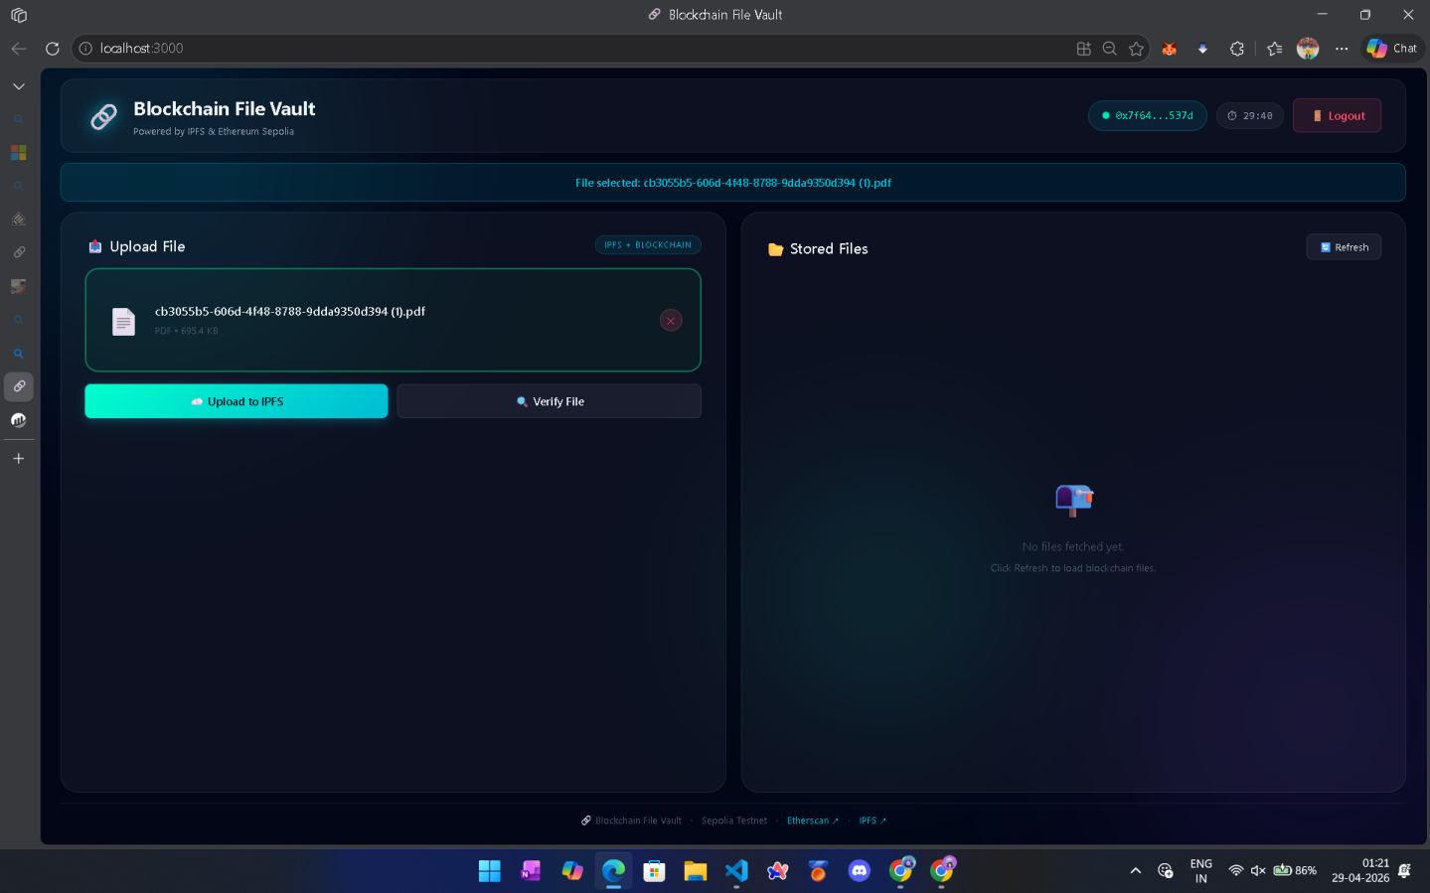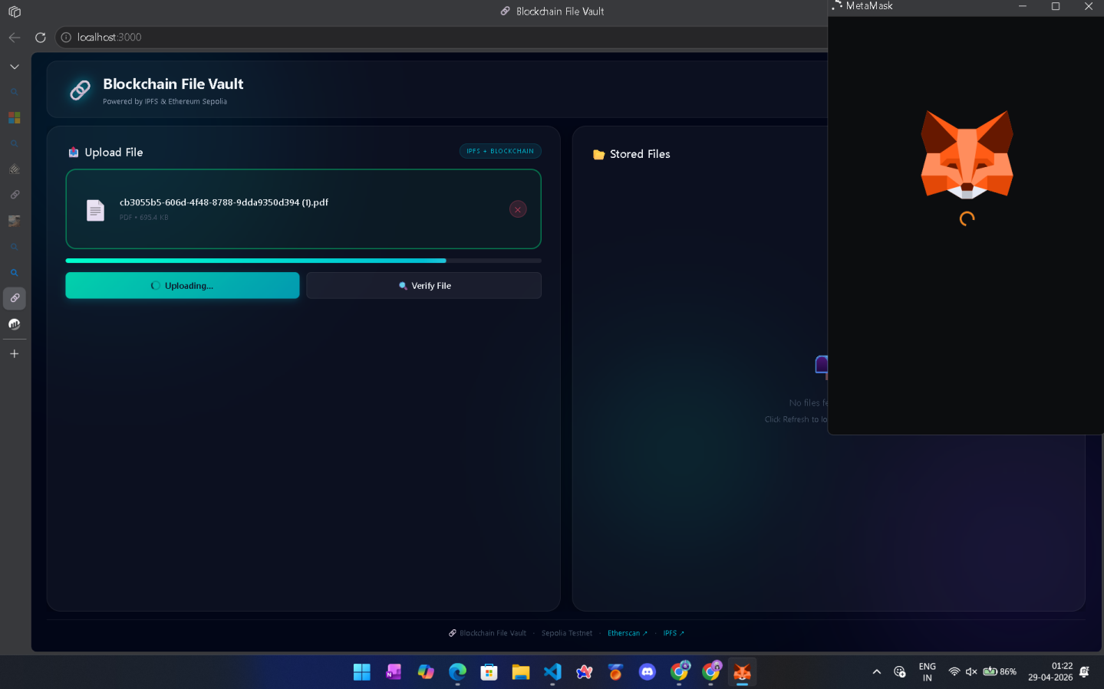

  - Hash Generation and Storage
Once the file is uploaded, IPFS generates a unique CID based on its content. This CID is then stored on the Ethereum blockchain using a smart contract, ensuring immutability.
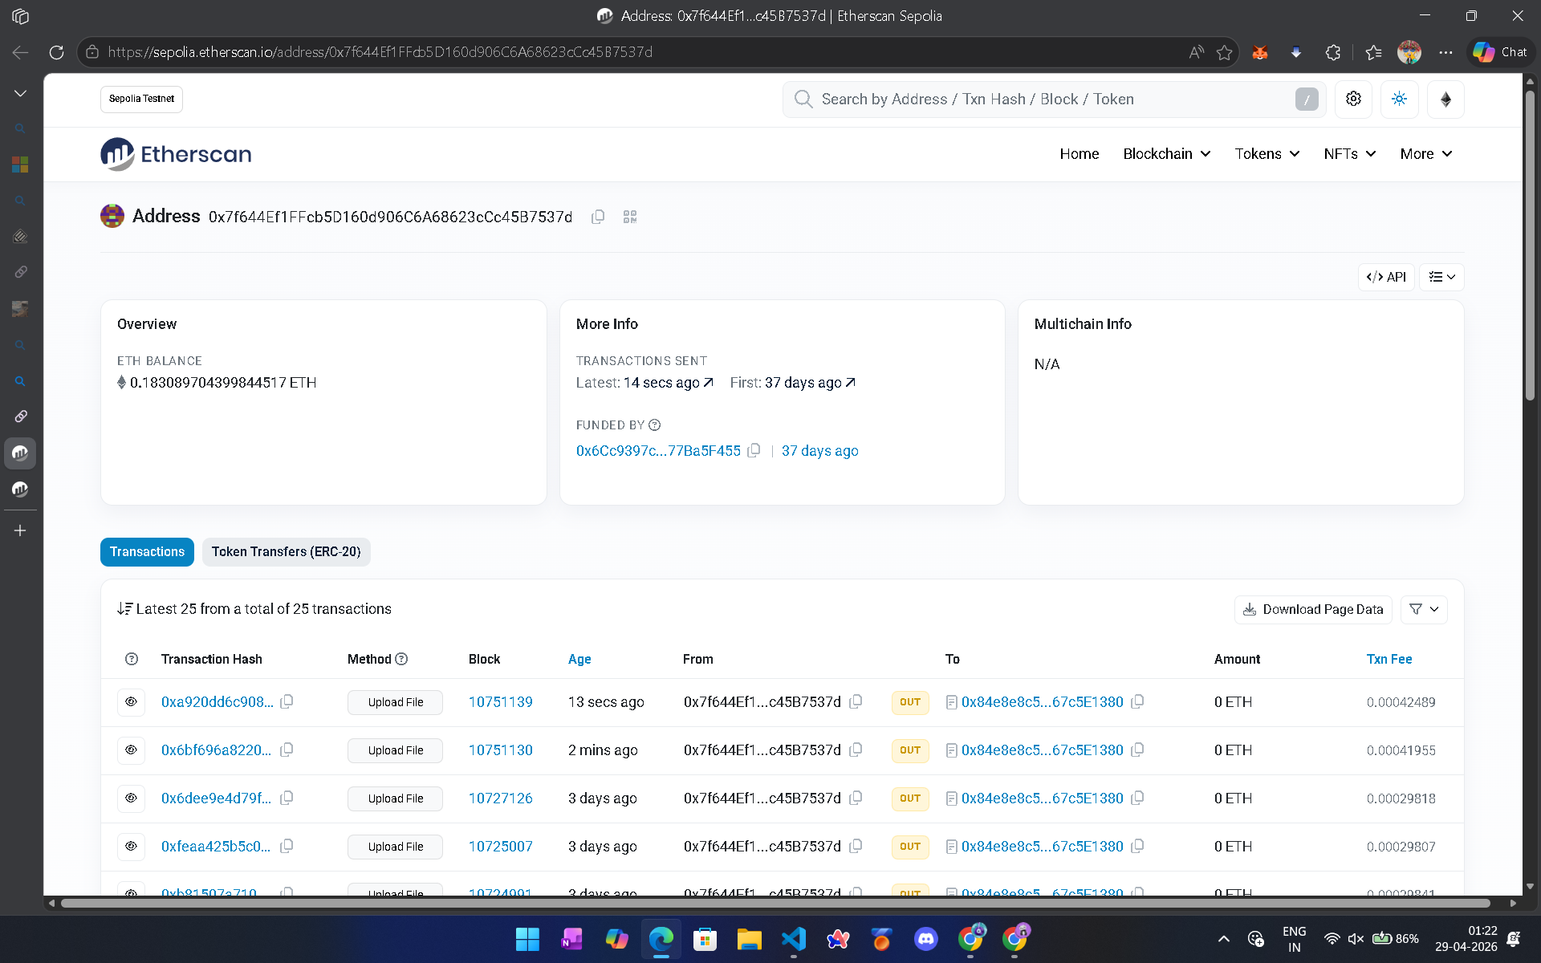

  - File Retrieval Process
When a user requests a file, the CID is used to retrieve it from IPFS. The decentralized nature of IPFS ensures that the file is available from multiple nodes.
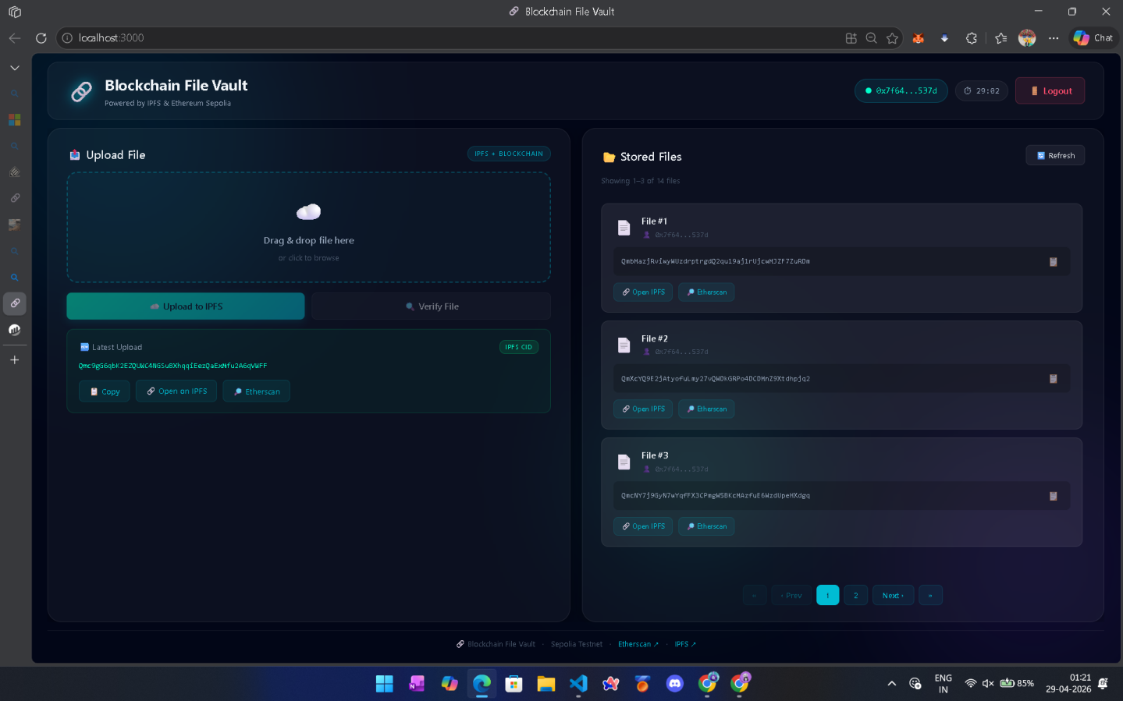

  - Integrity Verification
After retrieval, the system verifies the file’s integrity by comparing its hash with the stored CID. This step ensures that the file has not been altered.

- Results and Findings
  - Security Improvements
The system provides enhanced security by eliminating the single point of failure. The use of blockchain ensures that file hashes cannot be modified, making the system resistant to tampering.

  - Performance Analysis
The system performs efficiently in terms of storage and retrieval. Although blockchain transactions introduce slight delays, the benefits of improved security and transparency outweigh this limitation.

  - Cost Efficiency
By storing only file hashes on the blockchain and using IPFS for file storage, the system significantly reduces storage costs compared to fully blockchain-based systems.

- Conclusion and Future Scope
  - Conclusion
This project successfully demonstrates a secure and decentralized file sharing system using blockchain and IPFS. The system ensures data integrity, improves security, and provides transparency. It effectively overcomes the limitations of traditional centralized systems.

  - Future Scope
The system can be further enhanced by improving transaction speed and scalability. Integration with cloud platforms and mobile applications can increase its usability. Advanced encryption techniques can also be implemented to provide additional layers of security.

- References
- Blockchain-based storage research papers
- IPFS documentation
- Ethereum smart contract documentation
- IEEE research articles

